**WATER LEVEL MONITORING SYSTEM**

MINI PROJECT REPORT

for

21CSS201T - COMPUTER ORGANIZATION AND ARCHITECTURE

*Submitted by*

Vansh Srivastava [RA2311003011846]

Tejas Bahadur [RA2311003011820]

Ashmita Chakraborty [RA2311003011848]

*Under the Guidance of*

Dr. Sankara Narayanan

(Assistant Professor, Department of computing technologies)

*In partial fulfillment of the requirements for the degree of*

BACHELOR OF TECHNOLOGY

in

COMPUTER SCIENCE ENGINEERING

DEPARTMENT OF COMPUTING TECHNOLOGIES

SRM INSTITUTE OF SCIENCE AND TECHNOLOGY

KATTANKULATHUR- 603 203

NOVEMBER 2024

SRM INSTITUTE OF SCIENCE AND TECHNOLOGY

KATTANKULATHUR – 603 203

BONAFIDE CERTIFICATE

Certified that Computer Architecture and organization Mini Project report titled “**Water Level Monitoring System**” is the bonafide work of “**Vansh Srivastava” [RA2311003011846],** “**Tejas Bahadur” [RA231100301820],** “**Ashmita Chakraborty” [RA2311003011848],** who carried out the project work under my supervision. Certified further, that to the best of my knowledge the work reported herein does not form any other work

|  |  |
| --- | --- |
| **Dr. Sankara Narayanan**  **Guide**  Assistant Professor  Dept. of Computing Technologies | **Dr. NIRANJANA G**  **Professor & Head**  Dept. of Computing Technologies |

**INDEX**

|  |  |  |  |
| --- | --- | --- | --- |
| **CHAPTER NO** | | **TITLE** | **PageNo** |
| 1 |  | OBJECTIVE | 4 |
| 2 |  | ABSTRACT | 4 |
| 3 |  | INTRODUCTION | 5 |
| 4 |  | HARDWARE & SOFTWARE REQUIREMENTS | 6 |
| 5 |  | CONCEPTS WORKING PRINCIPLE | 6 |
| 6 |  | METHODOLOGY | 7 |
| 7 |  | OUTPUT | 8 |
| 8 |  | CONCLUSIONS | 9 |
| 9 |  | REFERENCES | 9 |
|  |  |  |  |

**WATER LEVEL MONITORING SYSTEM**

1. **OBJECTIVE:**

Water Level Monitoring System is to design and build a system that can monitor and alert users when the water level in a tank or container reaches a certain threshold. The system aims to provide both visual and audible alerts to indicate whether the water level is too high, too low, or at an optimal level. By utilizing basic electronic components such as transistors, resistors, light bulbs, and a buzzer, the system will help ensure efficient water management, prevent overflow, and avoid dry running of pumps in automated systems.

1. **Water Level Detection**: To design a system that can accurately detect different water levels using probes or sensors placed at predetermined heights within the tank.
2. **Indicator System**: To incorporate **light bulbs** as visual indicators to show when the water level is within safe limits, and a **buzzer** to provide an audible alarm in case of overflow or low water levels.
3. **Control Using Transistors**: To use **transistors** as switches to control the state of the indicators based on the water level readings, ensuring that the system activates or deactivates appropriately.
4. **Low-Cost and Simple Implementation**: To develop a system that is cost-effective, reliable, and easy to build using common electronic components, making it accessible for both educational and practical applications.
5. **Water Conservation and Safety**: To create a monitoring system that enhances water conservation efforts and helps avoid potential damage caused by overflows or insufficient water levels.

**2. ABSTRACT:**

The Water Level Monitoring System project aims to design and implement a simple yet effective system for monitoring and controlling the water level in a tank or container.

The system serves two primary functions: preventing overflow by alerting users when the water level is too high, and preventing dry running by warning when the water level is too low. By employing simple components, this project not only offers a low-cost solution for real-world applications (such as household water tanks, industrial reservoirs, and agricultural irrigation) but also provides hands-on experience with basic electronics, circuit design, and automation.

The system detects different water levels using probes placed at various heights within the container, triggering specific actions based on the water level. When the water reaches predetermined levels, the system activates visual indicators (light bulbs) and an audible alarm (buzzer) to signal the status of the water. Transistors are employed as switches to control the activation of these indicators. The system is designed to prevent issues such as overflow or dry running, ensuring both water conservation and operational safety. This simple yet effective solution can be applied to various domains, including domestic water tanks, agricultural irrigation systems, and industrial water reservoirs. The project highlights the potential of basic electronics in solving real-world problems while being easy to implement and cost-effective.

1. **INTRODUCTION:**

In today’s world, managing water resources efficiently is becoming increasingly important due to the growing demand for water and concerns over conservation. One common problem faced in both domestic and industrial settings is the lack of a reliable system to monitor water levels in tanks, reservoirs, or other storage containers. This can lead to issues such as overflow, water wastage, or insufficient water supply for various applications.

To address this problem, we have developed a Water Level Monitoring System that utilizes basic electronic components like transistors, resistors, light bulbs, and a buzzer. The primary purpose of this project is to create a simple, cost-effective, and automated system that can detect the water level in a tank and alert users when the water reaches a certain threshold. By providing both visual and audible signals, the system helps users to quickly respond to changes in the water level, preventing overflow or the risk of running out of water.

The system works by using water level probes placed at specific heights within the tank. These probes detect the presence of water, completing an electrical circuit when submerged. This change in circuit condition is sensed by transistors, which function as electronic switches, activating indicators such as light bulbs for visual indication and a buzzer for an audible alarm. The light bulbs will signal whether the water level is optimal or if it is too high or too low, while the buzzer serves as a warning in case of critical conditions like overflow.

This project is designed to be easily implemented using commonly available electronic components, making it both an educational and practical solution for a wide range of applications, from household water tanks to industrial water reservoirs and agricultural irrigation systems.

By automating the monitoring of water levels, the system not only helps conserve water but also improves safety and operational efficiency, making it a valuable addition to any water management system.

**4. HARDWARE/SOFTWARE REQUIREMENTS:**

Hardware details :-

1. **Resistors:** To limit the current flowing through certain parts of the circuit and to form voltage dividers where necessary.
2. **Transistors:** To act as switches for controlling the light bulbs and buzzer based on water level detection.
3. **Light Bulbs:** To provide visual indicators for the water level. For example, green for normal levels, red for high water, and yellow for low water.
4. **Buzzer:** To provide an audible alert when the water reaches critical levels (too high or too low).
5. **Battery:** To provide the necessary power to run the entire system.
6. **Wires:** To make all the necessary electrical connections between the various components.
7. **Breadboard:** To prototype and test the circuit before final assembly. A breadboard allows easy and quick assembly of the circuit without soldering, making it convenient for experimenting, troubleshooting, and adjusting the circuit during development.

**5. CONCEPTS/WORKING PRINCIPLE:**

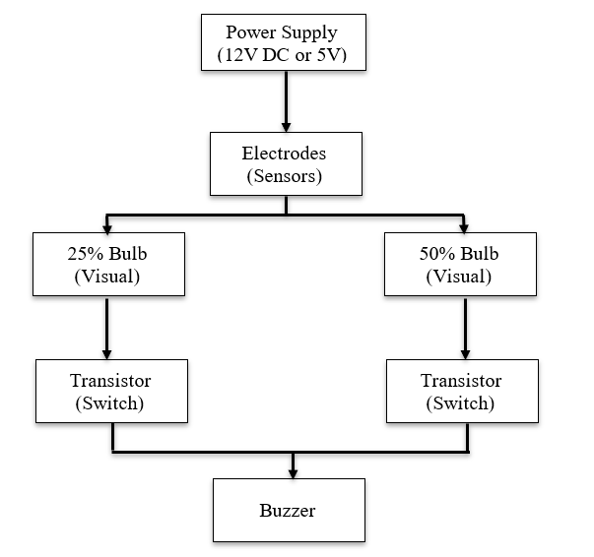

**6. APPROACH/METHODOLOGY/PROGRAMS:**

The methodology for building the Water Level Monitoring System is structured around key phases:

1. **Component Selection:** Transistors, resistors, light bulbs, battery, buzzer, breadboard
2. **System Design:** Create a schematic diagram and plan the power supply for the system.
3. **Circuit Design:** Design the circuit using transistors as switches to control the bulbs and buzzer based on water level inputs.
4. **Component Interfacing:** Connect the electrodes to transistors and the output devices (bulbs and buzzer) in the circuit.
5. **System Calibration:** Adjust electrode positions and test with water to ensure accurate detection of the 25%, 50%, and 100% levels.
6. **Testing and Validation**: Perform real-world testing with actual water to verify the system's performance and accuracy.
7. **Implementation:** Deploy the system in the field and monitor its performance.

**7. OUTPUT:**

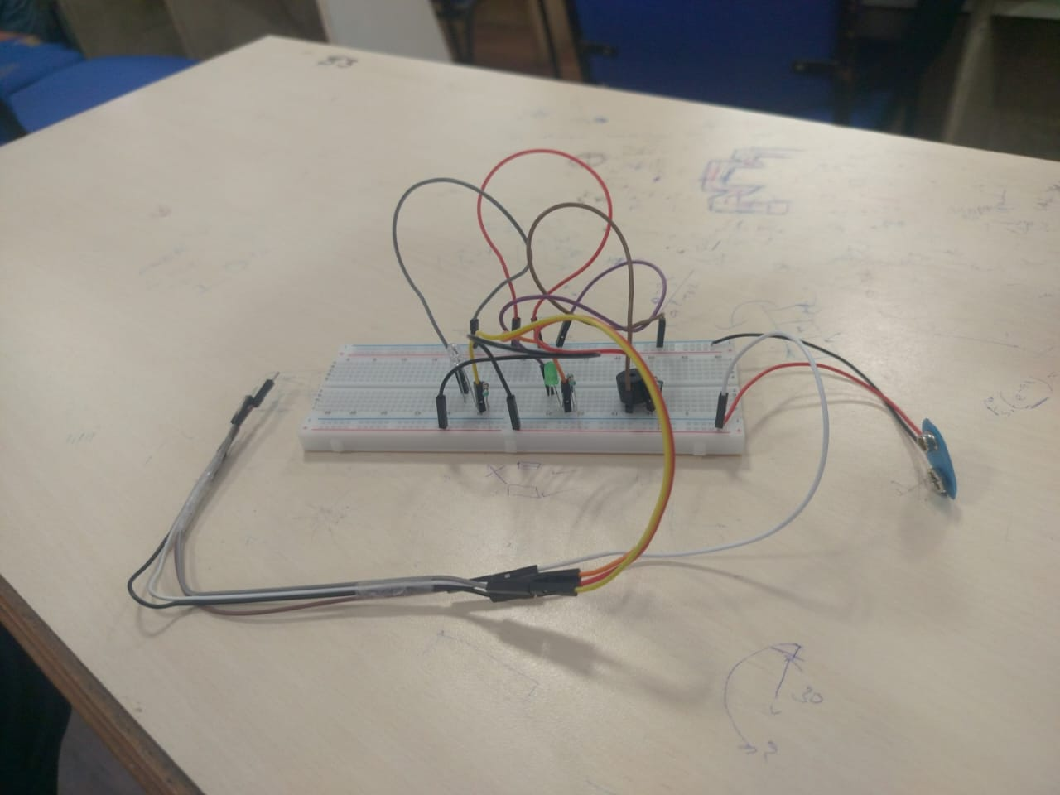

1. **CONCLUSIONS:**

Thus, Water Level Monitoring System developed in this project successfully addresses a critical need for efficient water management by providing an automated solution for monitoring and signaling water levels in tanks or reservoirs. Through the use of basic electronic components such as transistors, resistors, light bulbs, and a buzzer, the system detects and indicates whether the water level is within safe limits or requires attention. The visual and audible alerts provided by the light bulbs and buzzer make it easy for users to respond promptly to prevent issues like overflow or insufficient water levels.

The system has demonstrated its effectiveness in terms of simplicity, cost-efficiency, and reliability, offering a practical solution for a variety of applications, including domestic water tanks, industrial reservoirs, and agricultural systems. The use of transistors as switches to control the indicators based on the water level readings is both a cost-effective and robust approach, ensuring the system operates efficiently.

Furthermore, this project highlights the importance of using basic electronic circuits to solve real-world problems, providing an excellent example of how accessible technologies can be leveraged to improve water conservation, safety, and overall management. The system can be easily modified or expanded upon for more complex applications, and its low cost makes it an ideal starting point for both educational purposes and practical, small-scale water management solutions.

Overall, the Water Level Monitoring System fulfills its primary objectives of providing accurate water level detection, efficient alerts, and helping reduce the risks associated with improper water levels, making it a valuable tool in a variety of water management contexts.

1. **REFERENCES:**

<https://youtu.be/MnX36KHOw6Q?si=-m4LTH3hgCfnA-LR>

https://youtu.be/ufvQaIDpbHo?si=BtYhJpsTw5n5N0lU